# Introduction

## Brief back story

In a nation far away, Lords are trying to defeat each other to rule the whole continent.

## Game description

A strategy game where 2 players are trying to conquer dominions and take other’s Fort.

## General course of play

Each Lord starts from his Fort. During the game, a Lord can dominate neutral spaces through his General and send out his troops to invade his opponent.

## Goal (How to win)

A Lord wins the game when he takes his opponent’s Fort (Fort’s HP goes down to 0) or wipes out his opponent’s Troop.

# Game Components

## Board illustration

* The board contains 11 x 11 spaces.
* Each space can only hold 1 Character (See **Section 2.3**).

## Facilities illustration

## Forts illustration

* 2 Forts (Dark and Light) occupy 2 x 2 spaces in the diagonal corners of the board.
* Each Fort belongs to a Lord.
* Each Fort has 3 HP.
* Attacks on any the Fort space will accumulatively count as damage to the Fort.
* A Character must be recruited (See **Section 6**) in any empty space of the Fort.
* Once a Character moves out from the Fort, it cannot return to any spaces of the Fort.

## Strongholds illustration

* There are 5 Strongholds on the board.
* Forts and Strongholds cannot be dominated (see **Section 7.2.3**)

Fort

Stronghold

Fort

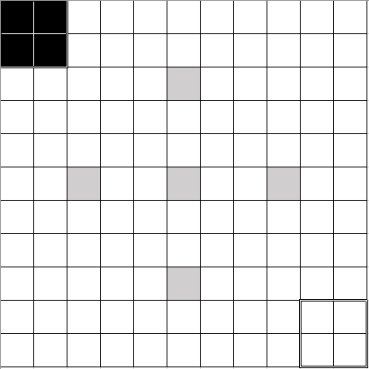

Figure 1 Gameboard

## Character illustration

* There are 5 types of Characters in total.
* Each Character has Maximum (Initial) HP, Movability, and Abilities.
* The Character Table in **Section 11** describes all types of Character.
* **Section 7.2** gives examples of abilities.

Lord needs to spend this amount of Action Point to take this Ability.

Spaces of every Action Point this Character can Move. See **7.2.1**.

Maximum (Initial) HP of this Character.

Abilities without costs are Passive Ability. See **7.2.2**.

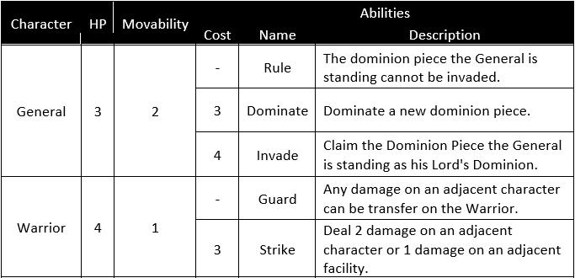

Figure 2 Example of the Character Table

## Character Token illustration

* Each Character will be represented as a token (Dark or Light) when they are on the board.
* A Token includes the Character’s name, icon, movability and HP marker.
* Use a binder clip to brace a token.
* The HP Marker pointed up indicates the current HP of the Character.

HP Marker

Icon

Movability

Name

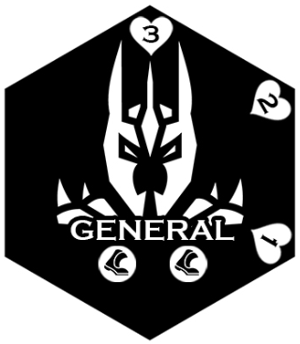

Figure 3 Head and tail of a token

The pointed-up HP Marker is 3, so the current HP of the Character is 3.

The pointed-up HP Marker is 2, so the current HP of the Character is 2.

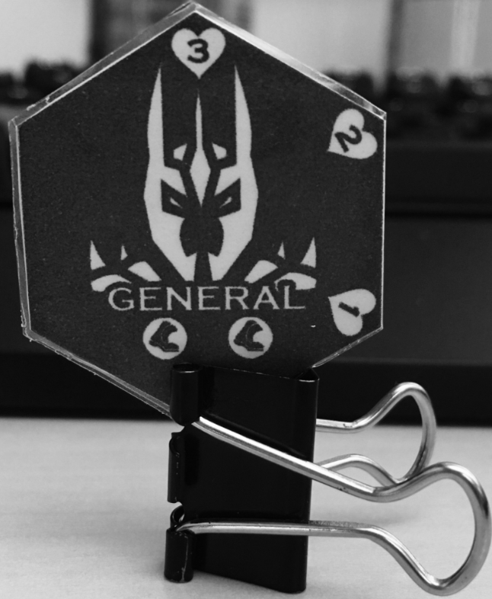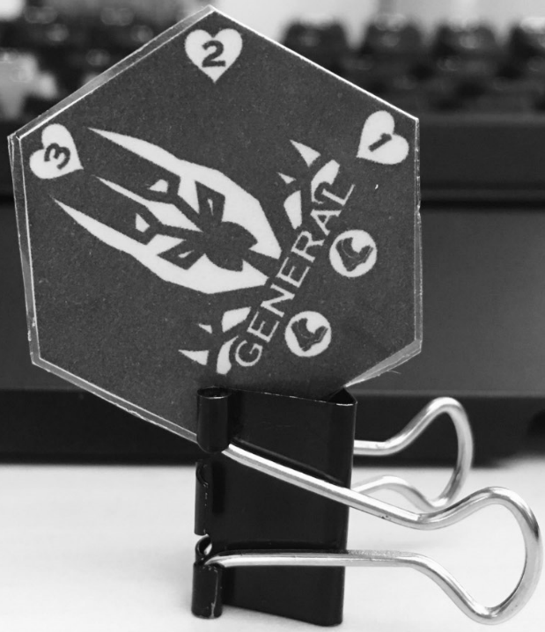

Figure 4 Examples of HP marker

## Troop illustration

* Lords build their Troop from the deck in the set-up process.
* A deck includes 13 Characters of 5 types, including 1 General and 3 of each other type.
* A Troop includes 5 Characters, plus 1 General.
* The player can only recruit Characters from his Troop during the game. The rest of the Characters of the deck will be abandoned in this game.
* If a Character was killed, he will be abandoned and cannot be recruited in this game.

## Dominion Piece illustration

* The General can dominate spaces into Dominion Pieces.
* Dominion Pieces are colored as their Lord’s color (Dark or Light).
* When a General dominates a new Dominion Piece, it must follow these rules:

1. It must be adjacent to the space where the general is standing on;

2. It must not overlap with other dominion pieces, Strongholds or Forts.

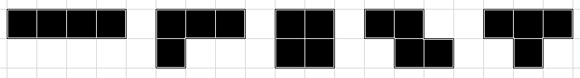

Figure 5 Examples of Dominion Piece

## Regular Tokens and Dice illustration

* The game needs 6 (as Action Points) + 6 (as Fort HP) regular tokens and at least a die.

# Setting up the game

## Laying out the game components

* Two players.
* Each player is represented by a Lord.
* Each player picks their side (Dark Fort or Light Fort).
* Each player builds their Troop as hands. A Troop includes 5 Characters. The maximum amount of the same Character is 3. Some examples of a Troop might be:
  + 2 Warriors, 1 Ranger, 1 Knight and 1 Sorcerers **[Recommended build for new players]**
  + 3 Warriors and 2 Rangers
  + 2 Warriors, 2 Knights and 1 Ranger
  + …
* Each player initiated with a General on the board. The player can decide which space of his Fort he wants to place the General initially.
* Each player set 3 regular tokens to represent the initial HP of his Fort.

## Play order

* Each player rolls a die. Higher roller goes first.

# Turn Order

1. Set Action Points
2. Recruit
3. Take Actions
4. Check for Victory
5. End of turn

# Set Action Points

* The Lord sets 6 regular tokens to mark their Action Points for this round.

# Recruit

## Explanation

* The Lord can spend 2 Action Points each to recruit Characters in an empty space of his Fort.
* This step can be skipped.

## Details

* A Lord can have 4 Characters at most on the board, including the General.
* Characters will be represented as tokens on the board (See **Section 2.3.1**).
* The Lord can recruit multiple Characters as long as he has enough Action Points.

# Take Actions

## Explanation

* Characters can spend Action Points to take Actions.
* This step can be skipped.

## Details

* A Character can take multiple actions in any order during a turn.
* A Character can take the same action for multiple times in a turn.
* There are 2 types of Actions, Movement, and Active Ability.
* Once the Character’s HP reaches 0, it dies and is wiped from the board to his owner’s hands immediately.
* Damage can be deal directly on a Fort, regardless there are Characters on it.

## Movement

* Characters take 1 Action Point Cost to make 1 movement.
* The number of Movability determines how much spaces the Character can move for each movement.
* A Character can take multiple movements in a turn.
* A Character can only move in a friendly and hostile dominion’s space or a stronghold.
* A Character can move across an ally, but cannot move across an enemy.
* Characters cannot stack on 1 space after moving.
* Whenever a Character move in a Hostile Dominion (enter, exit or on) during a movement, +1 Cost for that movement.

## Passive Ability

* Abilities without any Action Point Cost are Passive Abilities.
* Passive Abilities are always in effect during the player’s or his enemy’s turn.

## Active Ability

* Abilities with Action Point Costs are Active Abilities.
* Characters can spend Action Points Cost to take Active Abilities during the player’s turn.

## **Dominate** (the General)

1. A new dominion piece must be adjacent to the space where the general is standing on;

2. A new dominion piece must not overlap with other dominion pieces, Strongholds or Forts.

The General

New Dominion Piece can be place in any of these 3 space.

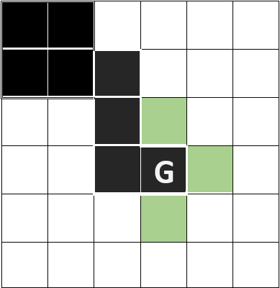

Figure 6 An example of using the Dominate Action of the General

## **Shoot** (the Ranger)

Deal 1 damage on one of the following:

1. An adjacent character or facility;
2. A character or facility that is 1 space away in a line if the Ranger is in a stronghold, or if there is no other Character between the Ranger and the target.

The Ranger CANNOT shoot the Warrior since there’s a Sorcerer between them. But he CAN shoot the Warrior if he’s in a Stronghold.

The Ranger CAN shoot the Warrior.

The Enemy Warrior.



Figure 7 An example of using the Shoot Action of the Ranger.

## **Space Warps** (Sorcerer)

1. Take the Sorcerer’s space as the rotation center;
2. Rotate the Dominion Piece that the Sorcerer is currently in.
3. Dominion Piece cannot overlap on any other Dominion Pieces, Strongholds or Forts.

In this example, the Dominion Piece can be rotated in this way.

There’s a Warrior in this space.



The Warrior will be rotated together with the Dominion Piece.

The Sorcerer. Take this space as the rotation center.

Enemy’s Dominion Piece. Cannot overlap.

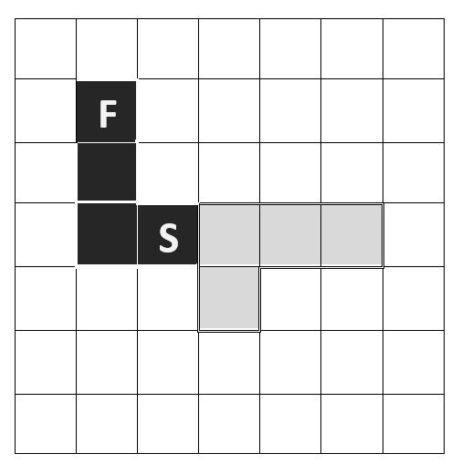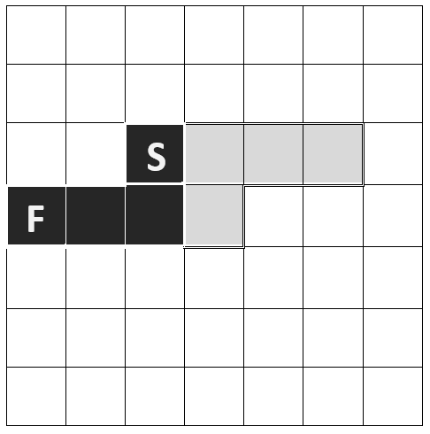

Figure 8 An example of using the Space Warps Action of the Sorcerer.

## **Dash** (the Knight)

Dash 6 spaces in a straight line unless The Knight reaches:

1. A hostile character, deal "the distance of the Knight has dashed to the target (including the target space)" damage on it. If the character was killed, stop in the target space; if not, stop in front of the character.
2. A Stronghold or the edge of a Dominion Piece, stop dashing.
3. The edge of the hostile Fort, deal 1 damage and stop dashing.
4. If there’s an ally Character in front of the target, and the dash couldn’t kill the target, the knight cannot dash.

Deals 2 damage (the distance of the Knight has dashed to the Fighter) to the Warrior. The Warrior has 1 HP left.

The Knight doesn’t kill the Fighter, so he stops dashing in front of him.

Enemy’s Warrior with 3 HP.

The Knight.

The Knight uses Dash

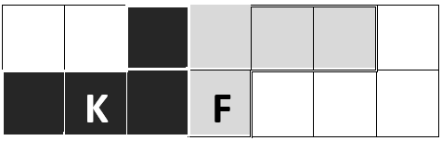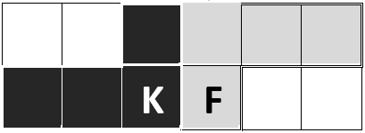

Figure 9 An example of using the Dash Action of the Knight.

The Knight deals 2 damage on the Ranger and kill him, so he stops dashing where the Ranger stood.

Enemy’s Ranger with 1 HP.

The Knight.

The Knight uses Dash

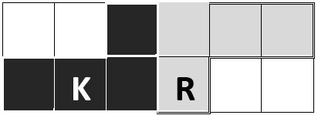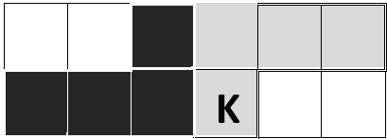

Figure 10 Another example of using the Dash Action of the Knight.

An ally

Enemy’s Warrior with 3 HP.

The Knight.



Figure 11 The Knight can’t dash because he can’t kill the enemy from a dash, and there’s an ally in front of the enemy.

# Check Victory

* Once the Lord’s Fort’s HP reach 0, he loses this game.
* If a player runs out of Characters that can be recruited, he loses this game.

# End of Turn

* The turn ends when the Lord runs out all Action Points.
* The Lord can abandon the rest of his Action Points to end his turn.

# Strategy tips

* Protect your **General**! You have only 1 General for each game, and he’s the only way you can dominate spaces.
* Your **Warriors** can be good guards for your General with his Passive Ability.
* Be careful to build straight paths when your enemy has a **Knight**! The Knight can deal a lot of damages when doing a Dash in a straight path.
* Place the **Ranger** in the Stronghold! Stronghold gives the Ranger a better vision to shoot the enemy.
* Your **Sorcerer** cannot deal any damage. But his Abilities can protect your units or mess up your enemy!

# Character Table

|  |  |  |  |  |  |
| --- | --- | --- | --- | --- | --- |
| Character | HP | Movability | Abilities | | |
| Cost | Name | Description |
| General | 3 | 2 | - | Rule | The Dominion piece the General is standing cannot be invaded. |
| 3 | Dominate | Dominate a new dominion piece. |
| 4 | Invade | Claim the Dominion Piece the General is standing as his Lord's Dominion. |
| Warrior | 4 | 1 | - | Guard | Any damage on an adjacent character can be transfer on the Warrior. |
| 3 | Strike | Deal 2 damage to an adjacent character or 1 damage on an adjacent facility. |
| Ranger | 2 | 3 | 3 | Shoot | Deal 1 damage on one of the following: 1. An adjacent character or facility; 2. A character or facility that is 1 space away in a line if the Ranger is in a stronghold, or if there is no other character between the Ranger and the target. |
| Knight | 3 | 1 | 4 | Dash | Dash 6 spaces straightly unless The Knight reaches: 1. A hostile character, deal "the spaces the Knight has dashed" damage on it. If the character was killed, stop dashing on the character's space; if not, stop in front of the character. 2. An empty stronghold or the edge of a dominion piece, stop dashing. 3. The edge of the hostile fort, deal 1 damage and stop dashing. |
| Sorcerer | 1 | 2 | - | Curse | Any Characters attacks the Sorcerer would suffer 1 damage after finishing the attack. |
| 2 | Space Warps | Take the Sorcerer's space as the rotation center and rotate the dominion piece he is currently in (cannot overlap). Characters on the dominion piece will be rotated together. |

# Design Notes

* The idea of the game is inspired by a virtual game called “Dungeon Dice Monsters (D.D.M)” from the manga Yu-Gi-Oh!. D.D.M has complicated rules, which prevent it from being as popular as Duel Monster, a well-known card game that also comes from Yu-Gi-Oh!. Inspired by D.D.M’s “Dimension” and “Monster Lord”, Lord of Dominion, a strategy game based on the concept of “Dominion” and “Lord”, was designed.

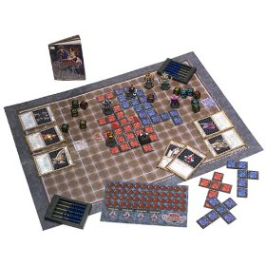

* The concept of “Dominion” also comes from other strategy games with the idea of “borders”, such as Civilization and Empire Earth.
* Starting from “Dominion”, the game needs a proper theme to match such a concept. Dungeon style was considered, but a lord of a dungeon doesn’t really need “dominions”. At last, the medieval fantasy style, with aggressive lords and their troops, was chosen.
* D.D.M is played on a 13 x 19 tile board (13 tiles wide), with a "Monster Lord" (which is also the attack target of each player) sits on the 7th tile from each side on the row closest to the players. The vertical design of the board makes the dimension pieces tend to squeeze in the middle part of the board, leaving the left and the right sides to be blank. Inspired by MOBA games, Lord of Dominion set the attack targets, the 2 Forts, on the diagonal corner of the board instead.

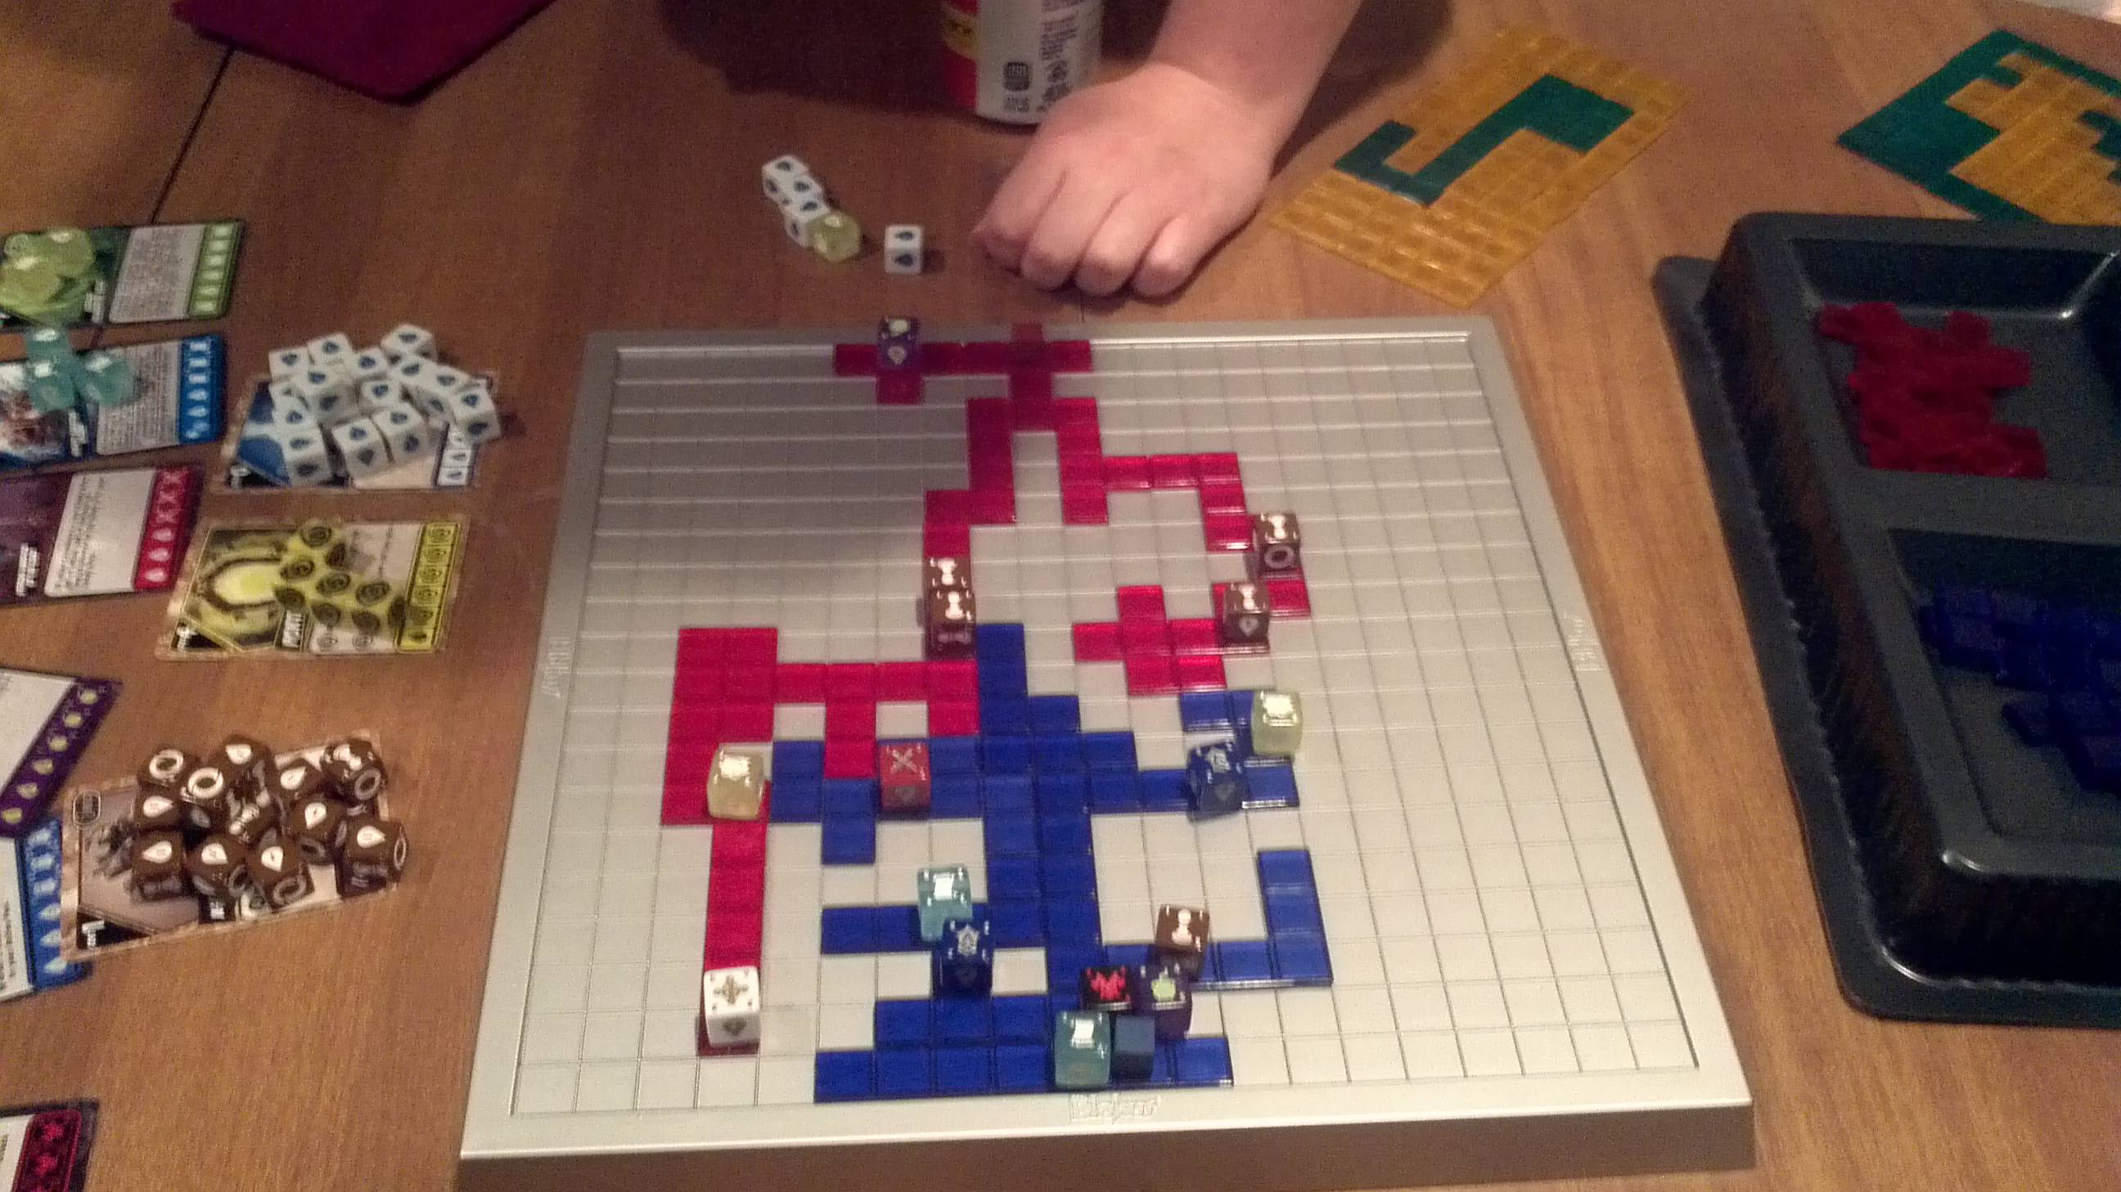

* To make better use of the whole game board, referring to the concept of “Jungle” from MOBA, Lord of Dominion sets 5 Strongholds evenly on the board. The Lord who occupies a stronghold will have more advantages, so they will be more willing to spread their dominions to occupy the strongholds instead of just squeezing them in the shortcut to their enemy’s fort.

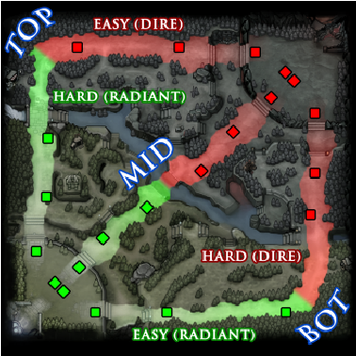

* D.D.M has random factors like card deck and dice rolling, which makes the game relying on luck. To raise the importance of strategy, Lord of Dominion doesn’t adopt these random factors.

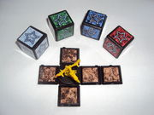

* Similar to D.D.M, in Lord of Dominion, dominating Dominions was once a separating step in the game. However, it increases the complexity of the game, making it harder to learn and to remember for naïve players. Hence, it was integrated into the General’s abilities later.
* Character design takes the classic DND and RPG settings as references. Warrior, Ranger, and Sorcerer are the first 3 characters designed for the game.
  + Warrior was designed as the basic attacking unit in the game at the very beginning. Later, to distinguish the Warrior and the new Character Knight, he was modified to be more defensive, with high damage but low movability, and the ability to protect friendly units around him.
  + Ranger was designed as the only long range unit in the game. He has high movability as well. In the first few versions, he has the ability to enter spaces that have not been dominated. However, this ability turned out to be overpowered in the playtests. In addition, the calculation of moving cost is confusing when the Ranger moves between dominions and neutral spaces. Therefore, it was removed.
  + Sorcerer is different from the traditional Wizard. Instead of being another attacking unit using magic, it was designed as a unit that creates chaos in the battlefield without dealing any damage.
* Knight is initially designed as the most powerful unit with high movability, high damage but high cost and limited by the terrain. In the latest version, to balance the game, he doesn’t have the high movability anymore unless he does the Dash ability. Meanwhile, the difference of his cost was erased to simplify the game.
* General is designed as a substitute for the dominating action. He is also an important, rare, strategical unit that cannot be additionally recruited.

# Version Log

## V 5.0.0

* Changed the board from *13*13* to *11*11* to increase the speed of the game.
* Reduce Action Points for each round from 12 to 4 to reduce the time of each turn. Player was waiting too long during other player’s turn. The number of 4 also makes decisions of actions to be more careful, because it limited the possible action combinations for each turn.

## V 4.0.0

* Changed the concept of Action. Now there’re 2 types of Action: “Movement” and “Abilities” – to make the rule of movement clearer.
* Use designed tokens instead of dice.

## V 3.0.0

* Each player initiates with a general – so that they can dominate at the beginning of the game.
* Reduced the character count of a troop from 10 to 5 – 10 is too much for a new player to build.
* Simplified actions’ descriptions to fit on the card.

## V 2.0.0

Update:

* Changed the board from *15*15* to *13*13*.
* Canceled Deck.
* Canceled dice for action points. Now each Lord has 12 action points each round.
* Changed the function of the Strongholds.
* The player can build their Troops at the beginning of the game.
* Added new action of General: Dominate. Now the Lord no longer dominate through cards but his Generals.
* Increased movement speed generally.
* Added new aggressive Characters: Knight, Assassin
* Deleted non-aggressive Characters: Scout, Chancellor

## V 1.1.0

Update:

* Changed the number of player from *2 or 4* to *2*.
* Completed the rule of occupying a Stronghold.
* Reduced the number of Dominion Piece Cards from *17* to *10*.
* Changed the number limitation of the Characters on board for each Lord from *3* to *4*.

Feedback:

* The game is too long.
* Too much Character Card.
* Characters are too hard to be killed, making the game too slow and the Character Cards in hands to be meaningless.
* Characters tend to be stuck at the Strongholds.
* Too much random factors.

## V 1.0.0

Feedback:

* The game is too long.
* Too much Dominion Piece Card.